Inject 1.5 Report from Mega.nz regarding account of samtheman8300@gmail.com
The following email has been received as a result of your data request.
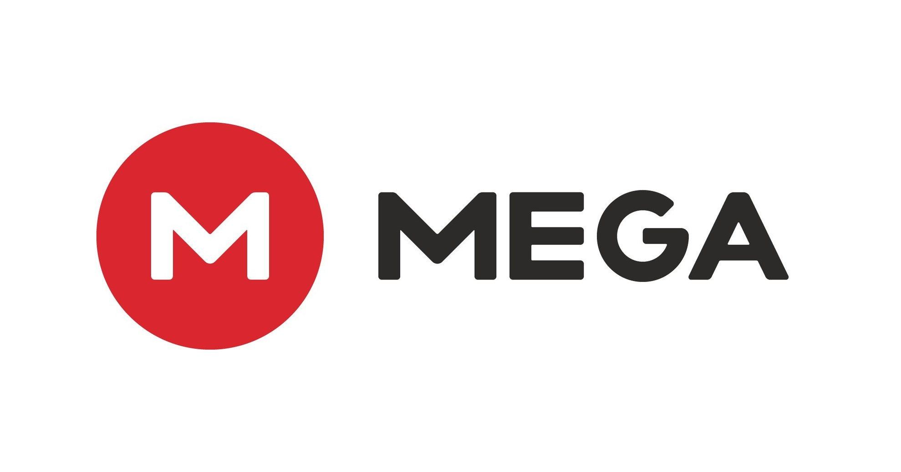

To: LEA
From: Legal@mega.nz
Subject: Data request – Urgent CSAM Threat to Life

Further to your urgent enquiry, we can confirm an account is held for email address samtheman8300@gmail.com it was registered on 9th May 2021 at 09:07:33UTC from IP address 92.250.136.18, our logs show only registration and two log-ins.

92.250.136.18 | 05/09/2021 09:18:03 UTC | Win
37.77.16.53 | 05/26/2021 07:30:45 UTC | Win
Please note our policy: MEGA may not require a court order for release of information and may be prepared (but shall not be obligated to) retain information while disabling user access to it, for evidential purposes.

In light of our policies it is intended to suspend this account unless otherwise advised by LEA or Judiciary within 24 hours. Logs will be preserved for 90 days as requested.

Yours Faithfully

Sam Mendez
Legal Dept Mega.nz

Mega Limited
Level 21, Huawei Centre
120 Albert St
Auckland
New Zealand

