Inject 2.7.1 Data Request to M247 SRL for IP Address 194.59.249.254 Hendrix
Report from M247 Europe SRL, Soseaua Fabrica de Glucoza, 11B, etaj 1, sector 2, Bucharest 020331, Romania in relation to IP address, 194.59.249.254 used on 20th May 2021 at 09:43:12.

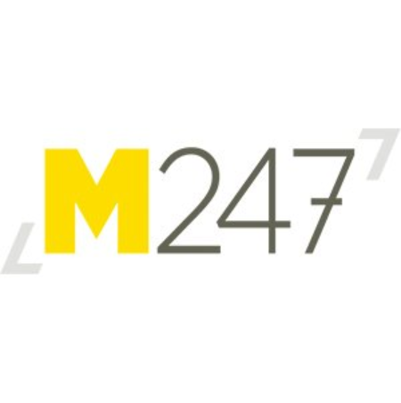
M247 Europe SRL
Soseaua Fabrica de Glucoza, 11B,
etaj 1,
sector 2,
Bucharest
020331,
Romania

Subject: Urgent Data Request – Threat to Life.

Further to your urgent request for data and subscriber information concerning IP address, 194.59.249.254 used on 20th May 2021 at 09:43:12.

Our records show that the IP Address 194.59.249.254 on 20th May 2021 at 09:43:12 is allocated to Mme Nora Tinguali, Café Patisserie de L’Alma, 98 Rue de L’Alma, 59100, Roubaix.

This is a business client of M247 Srl since 23rd October 2017, this company has subscribed to our MConnect 500Mbps Internet Services.

M247 provide this information for urgent Police and Judicial investigation purposes.

For evidence in judicial proceedings a formal judicial order will be required from an appropriate judicial authority.

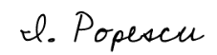

Iona Popescu
M247 Europe Srl, Legal Team

M247 Europe S.R.L., Registered in Romania: J40/3081/2015; VAT No: RO30203422
Subsidiary of M247 U.K. Limited.

